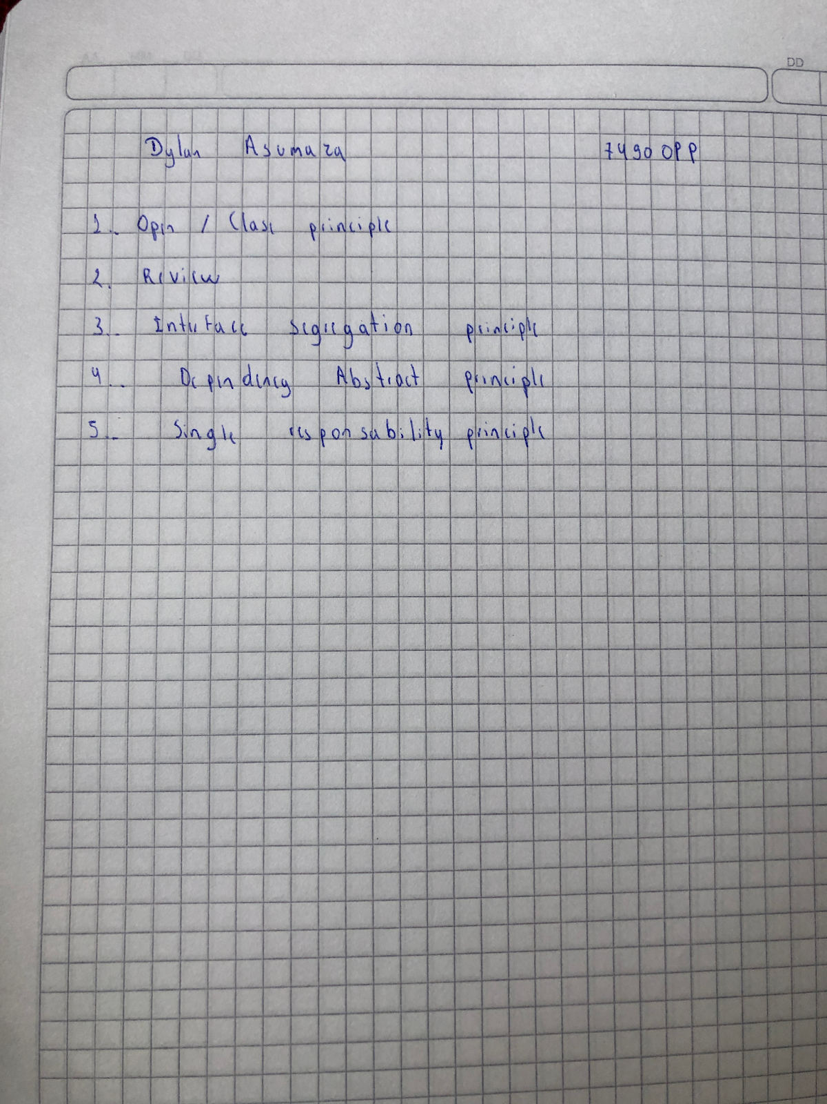

**TEAM 6:**

Alex Andrango

Anderson Almache

Dylan Asumaza

Cristhian Altamirano

Andrea Tapia

Change button variable name Exit

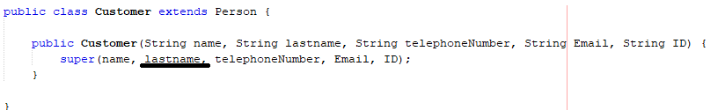Cammel Case

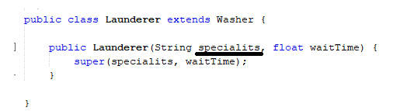

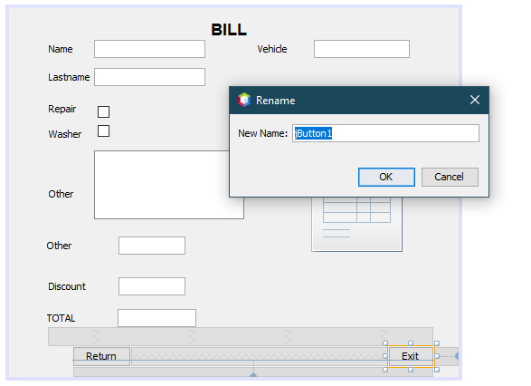

Name of the buttons

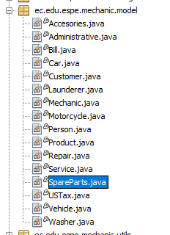some classes are written in plural

Default comments are not deleted

